In his name

Abu-Dhabi Hoteling Automation System

(ADHAS)

# Overview

You have to develop a software solution in multiple platforms (desktop, mobile and web applications) to cover all needs in an integrated and comprehensive way.

You have been asked to analyze and develop the solution based on following scenario.

# Hotel Rules

This hotel has individual levels for different servicing methods.

* Welcome level (3)
* Member level (2)
* VIP level (1)
* Employees level (E)
* President level: Top rated employee (P)

People in level 1 and 2 must be registered in system and they have a magnetic card which has their info and image printed on. This magnetic cards will be used also as a key to different units such as rooms, parking, saloons, halls, and … in hotel.

Employee level are infrastructure units of hotel such as the kitchen, and warehouse. Presidents are also employees who are top rated and can access any place any time. Such as IT System Administrator, CEO, Electrical Emergency Chief and Medical Chief.

The customer who has a room in service, necessarily must gather a valid national document such as national identity card or passport.

Customer id card is the key to almost everything.

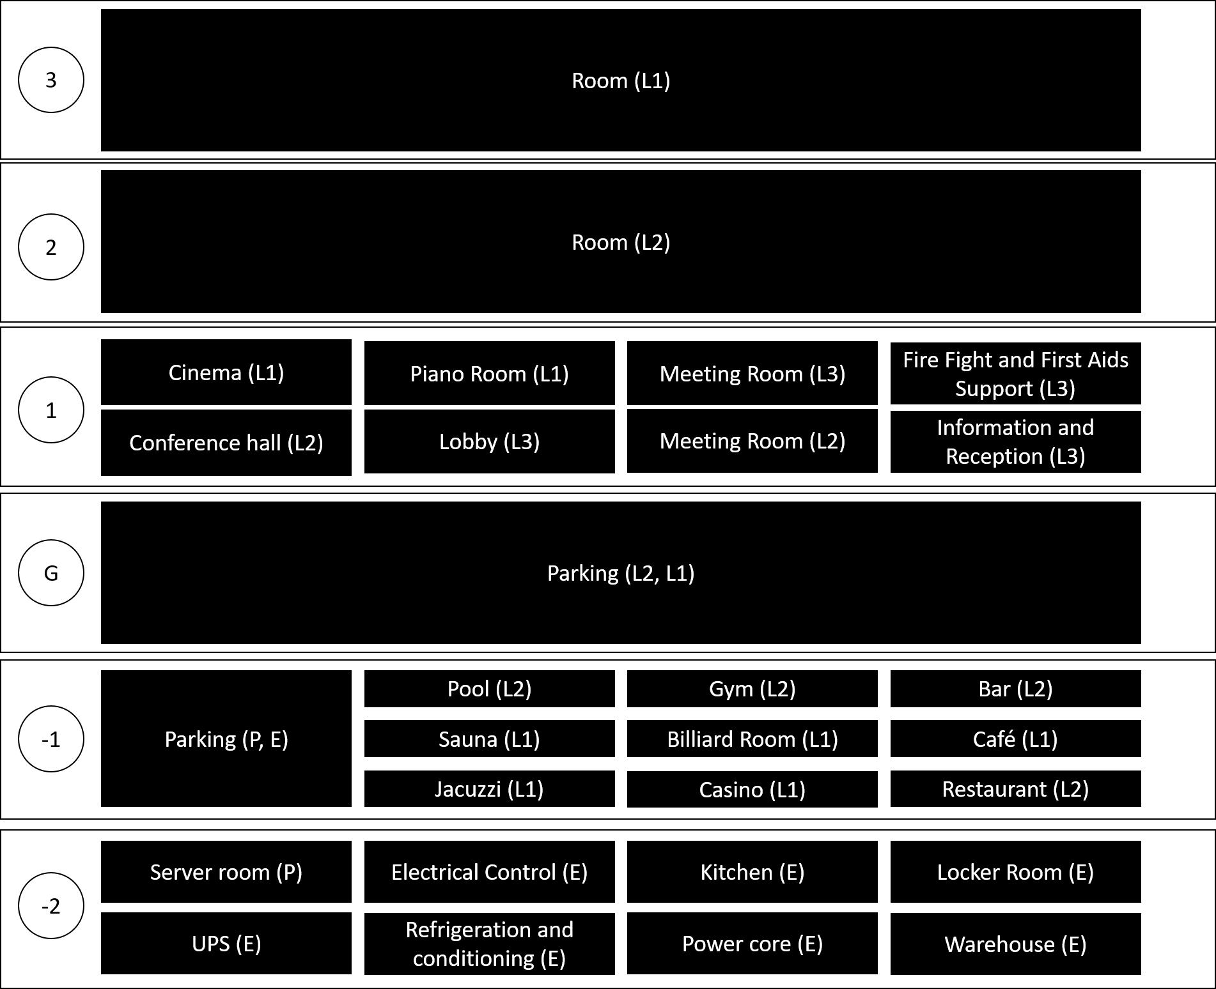

# Guest Registration

There is a web based application that allows users to register to system and submit their info and upload national documents scans with an image.

Employees

Every employee can be active in multiple positions in same time. It means that you must develop a main screen which will be dynamically customized for each employee who Is logged in to system.

# Guest Reception (Attendance in person)

Receptionist can deny a customer from a unit; for example, youth adults are denied from attending bars. Receptionist will print out the magnetic card for whole family that they will have their own profile and registration; but the reservation will be named for just one.

Customers can reserve a room for a while and they can extend it only if there isn’t any reservation after or the conflicting registration is canceled.

Scheduled time for each unit must be visualized on a Gantt chart available to employees and presidents.

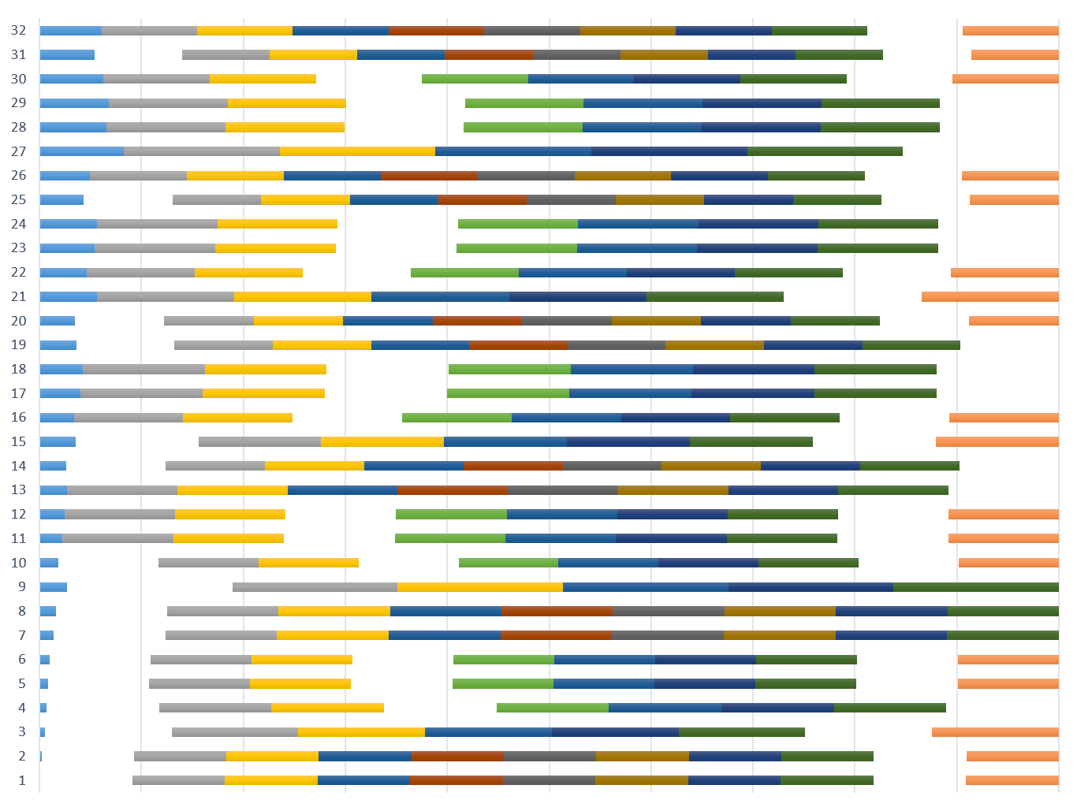

# Units

There are three types of units; PRIVATE, ALWAYS ON and SHOWTIME.

* Private Units such as Rooms, Parking, Safe box.
* Always On Units such as Gym, Bar, Café, Casino, Lobby.
* Showtime units such as Cinema, Conference hall.

# Service Times

There must be no conflict between service time and customer rest time. Private unit services are scheduled and requested by the customer. Showtime units will have auto scheduled service after each program. And Always on units will have services customized periodically (e.g.: each hour, each four hours, each day, two times a week)

Service employees have the right to access to requested room in allowed times. Presidents have the right to access any unit any time.

# Magnetic Card Concept (Mobile)

You have been asked to develop a mobile application that will check the access permission to unit based on identity card serial.



# User Monitor (Mobile)

This form allows employees to check people identities and download info.



# User Registration (Web)

Note: Receptionist will gather the physical document for each reservation.



# Login (Desktop)

There is a single desktop application that handles operations for almost all users in system.

There will be a login form as welcome screen and users will be authorized and redirected to their own menus after authentication.



# Employees main menu

Main menu is outline as below.



As you know, tabs will visible to employee if he/she has position in that unit.

# Customer main menu

Customer doesn’t need password to access the application. The app is available on a tablet inside their room. So the room has an identifier that program will handle all requests through.



# Profile



# Parking

When operator clicks on each parking, “Parking reservation” form will be displayed. In use places must have a graphical difference.



# Parking reservation





# Kitchen and Restaurant



Guests will enter the restaurant and they will choose their preferred menu after taking a seat.

# Seat Reservation

